1.     Create AFTER UPDATE trigger to track product price changes

--create product_price_audit

CREATE TABLE product_price_audit (

audit_id SERIAL PRIMARY KEY,

product_id INT,

product_name VARCHAR(40),

old_price DECIMAL(10,2),

new_price DECIMAL(10,2),

change_date TIMESTAMP DEFAULT CURRENT_TIMESTAMP,

user_name VARCHAR(50) DEFAULT CURRENT_USER

);

select * from product_price_audit;



--create trigger function

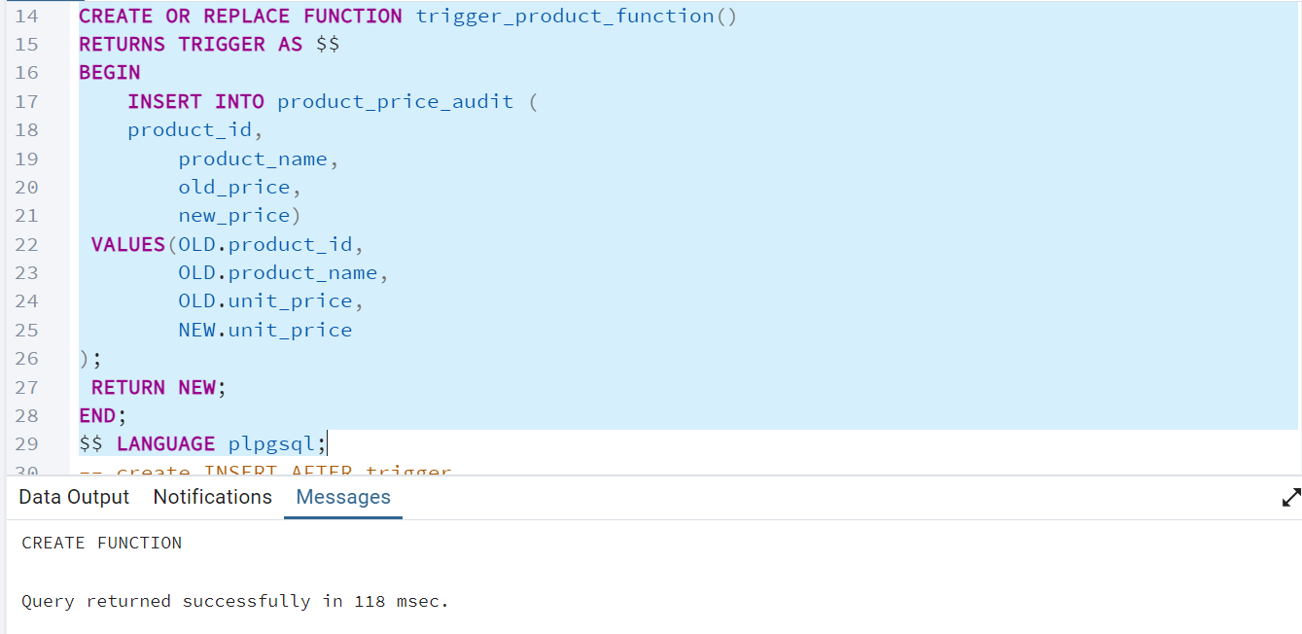

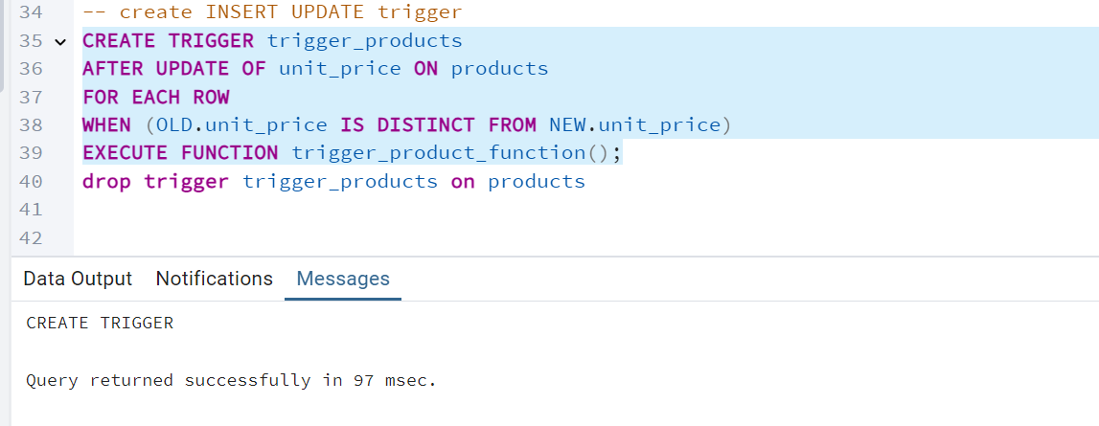

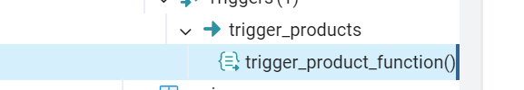

·        Test the trigger by updating the product price by 10% to any one product_id.

